**Experiment No. 02**

* 1. **Experiment Name**

Introduction to MATLAB Simulink Tools

* 1. **Objectives**
* To learn about MATLAB tools and how they work
* To become acquainted with various library functions
* To become acquainted with the Simulink platform and Simulink library
* To simulate various types of circuits using blocks from the library browser.
  1. **Theory**

Simulink is a MATLAB-integrated simulation- and model-based design environment for dynamic and embedded systems. It is essentially a graphical block diagramming tool with a set of block libraries that can be customized.

For this experiment, following library functions are used in different circuits to observe their output.

* + 1. **MATLAB Function**

The MATLAB Function blocks allow users to define custom functions in Simulink models using the MATLAB programming language. Simulink Coder and Embedded Coder can generate C/C++ code in MATLAB Function blocks. There are no continuous or discrete dynamic states in the custom functionality that you want to model.

* + 1. **Mean**

The Mean block computes the input signal's mean value. The mean value is calculated over a one-cycle running average window of the specified fundamental frequency:

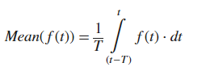

f(t): Input signal, T = 1/fundamental frequency

* + 1. **Absolute**

The Abs block returns the input's absolute value. The absolute value of the most negative value is not representable by signed-integer data types. In this case, the Saturate on integer overflow check box governs the block's behavior. The Abs block can detect zero-crossings.

* + 1. **Sample and Hold**

When a trigger event is received at the trigger port, the Sample and Hold block acquires the input at the signal port (marked by). The output is then held at the acquired input value until the next triggering event occurs.

* + 1. **Phase- Locked Loop (PLL)**

A phase-locked loop is a feedback system that combines a voltage-controlled oscillator and a phase comparator to adjust the oscillator frequency or phase to track phase-modulated signal.

* + 1. **Half wave & Full wave rectifier**

Half-wave rectifier is a circuit that only passes one half of the input sine wave. Full-wave rectifier is a circuit that converts both polarities of the input AC waveform to pulsating DC.

* 1. **Apparatus**
* Simulink
  1. **Simulink Block Diagram & Waveform**
* **MATLAB Function**

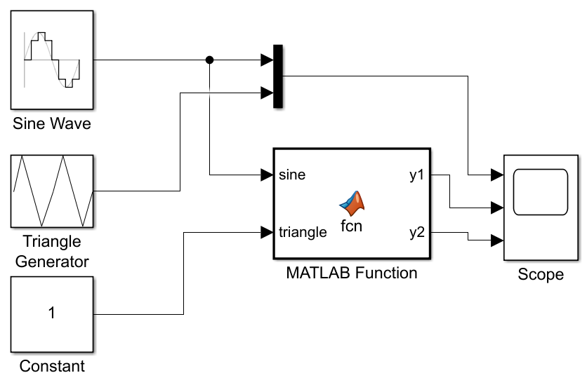

*Fig 2.1: Block diagram with MATLAB function*

* **Code**

function [y1, y2] = fcn(sine, triangle)

%codegen

S1=abs(sine)

S2=(1+triangle)/2

if S1>=0.5

y1=1;

else

y1=0;

end

if S2>=S1

y2=1;

else

y2=0;

end

end

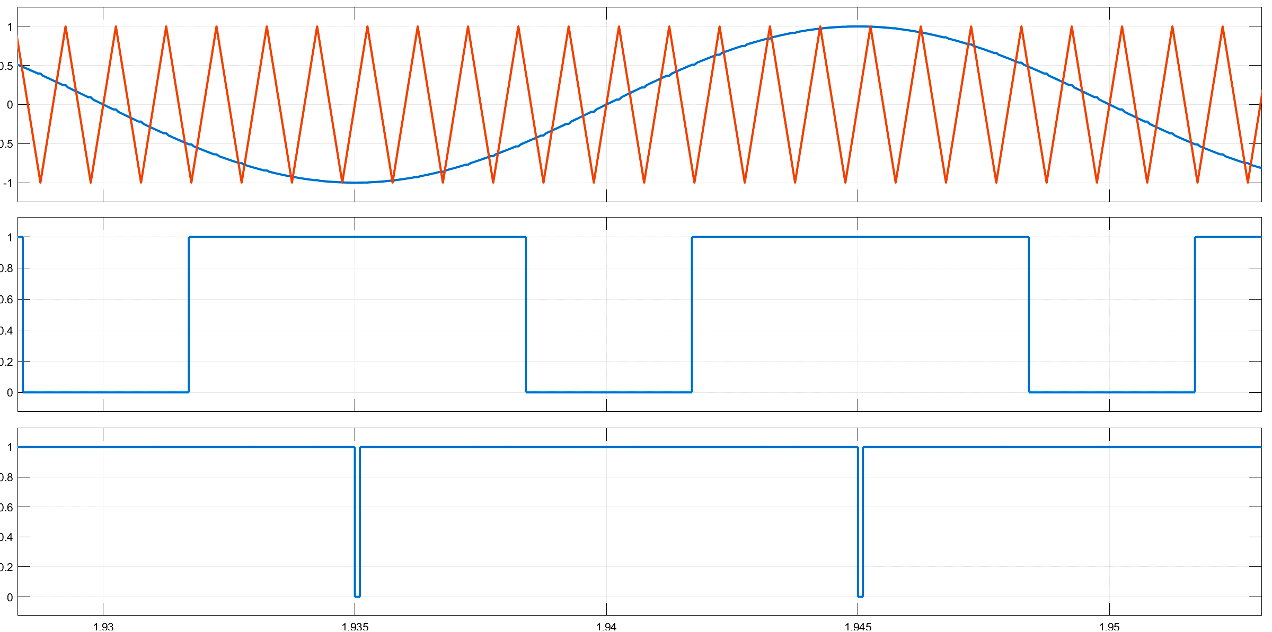

*Fig 2.2: Input & Output waveform of sine and triangle wave using MATLAB function.*

* **Mean**

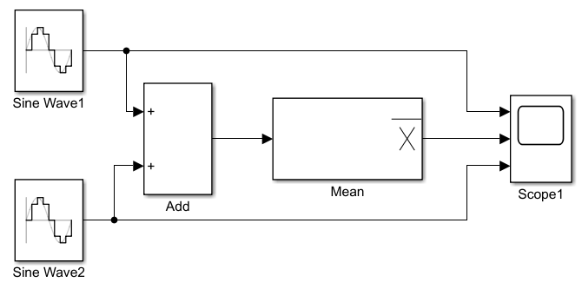

*Fig 2.3: Block diagram with mean value*

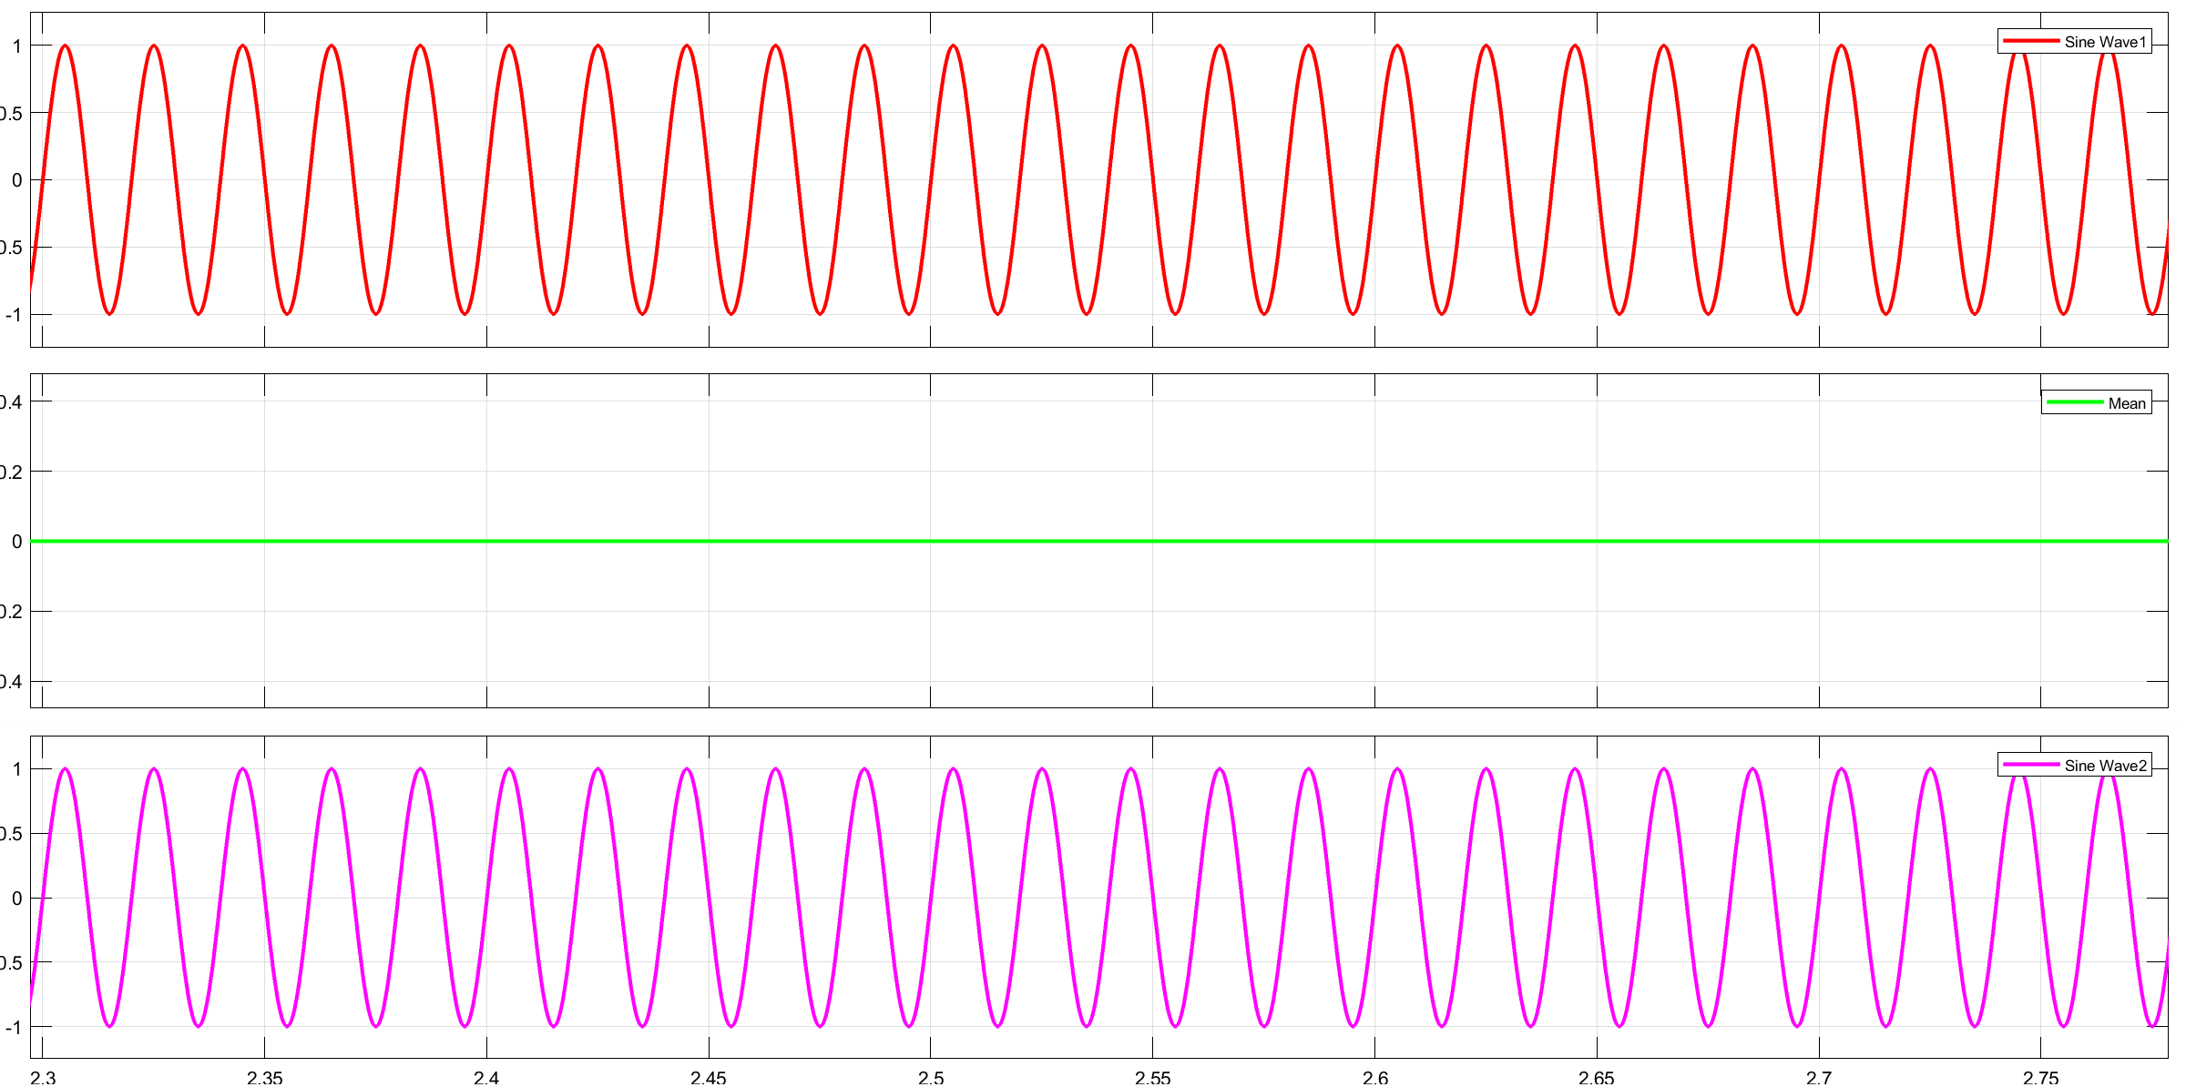

*Fig 2.4: Input & Output waveform using Mean block function*

* **Absolute Function**

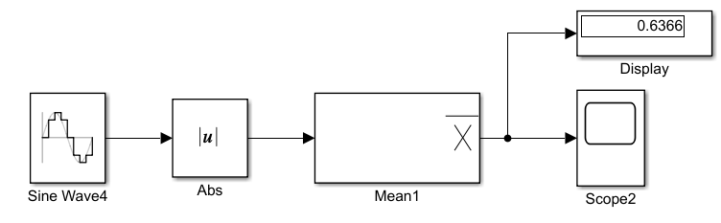

*Fig 2.5: Block diagram with abs and mean value*

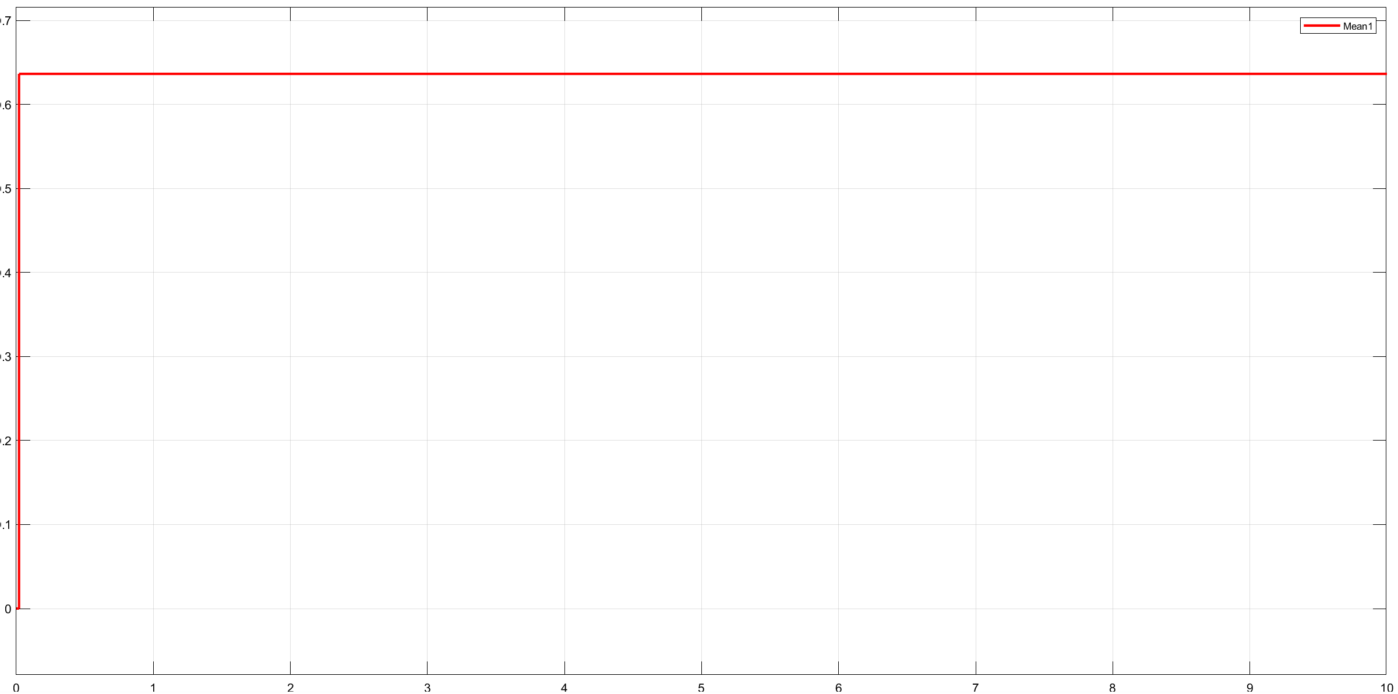

*Fig 2.6: Output waveform using Abs block function*

* **Sample and Hold**

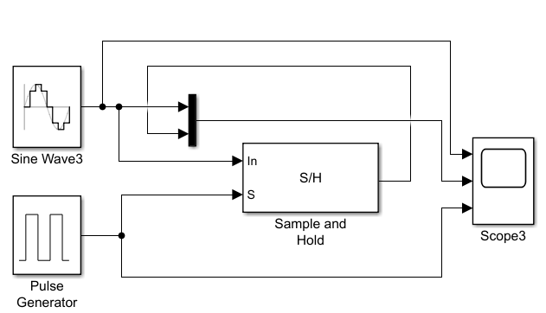

*Fig 2.7: Block diagram of a sample and hold circuit*

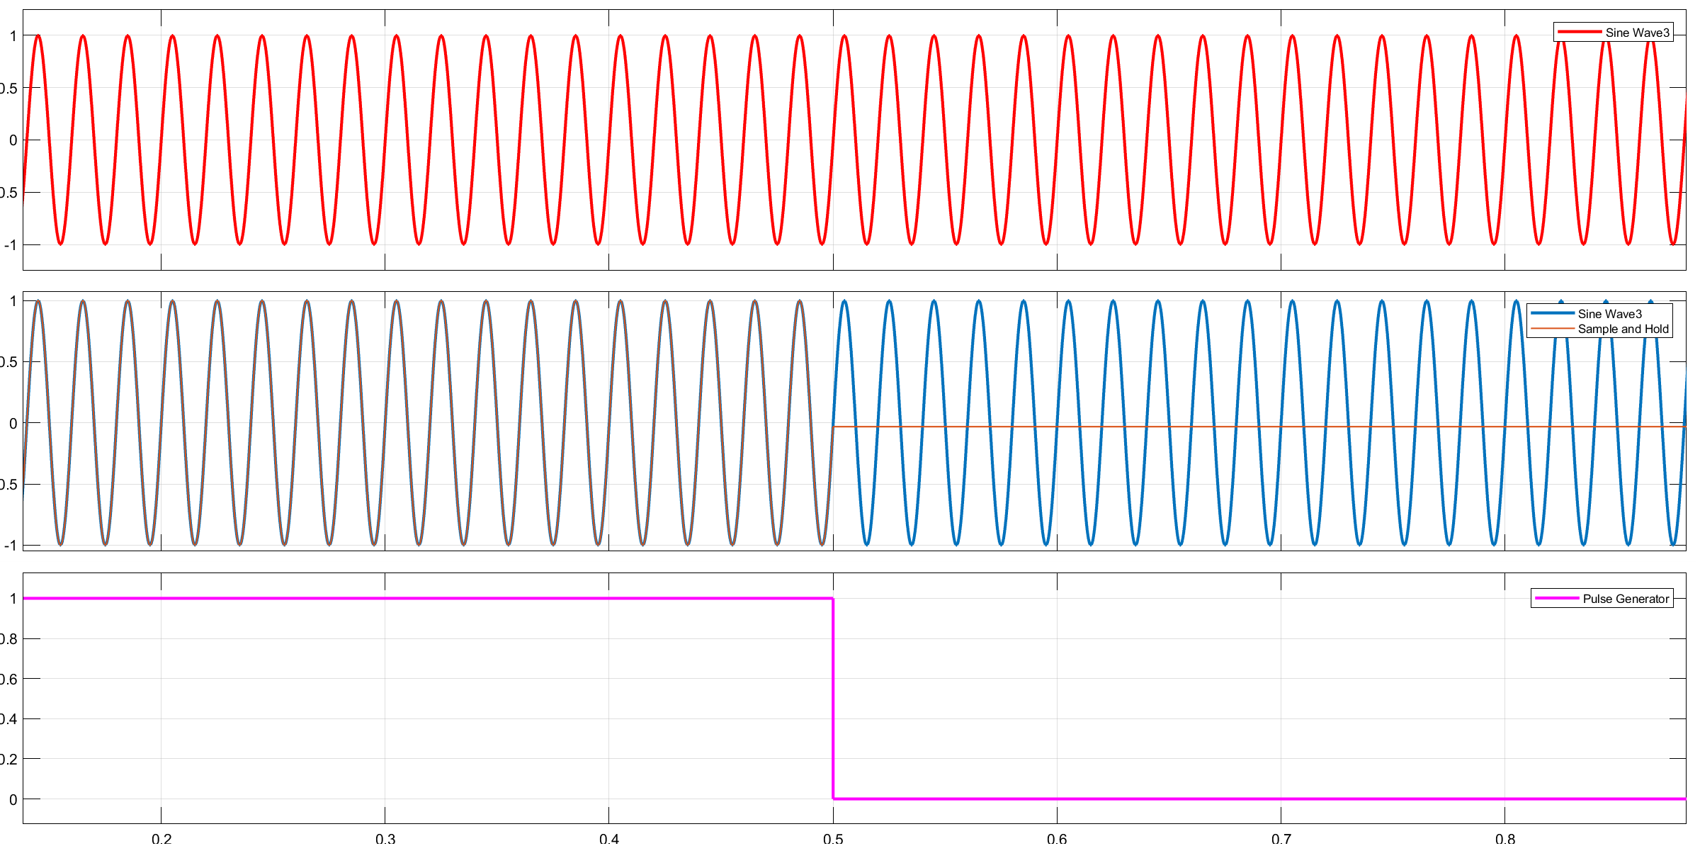

*Fig 2.8: Input & Output waveform for Sample and Hold circuit*

* **Phase- Locked Loop (PLL)**

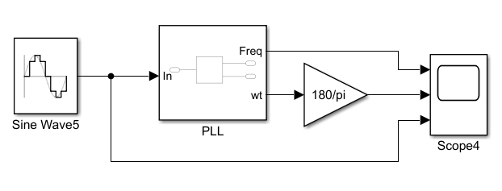

*Fig 2.4: Block diagram of a PLL circuit*

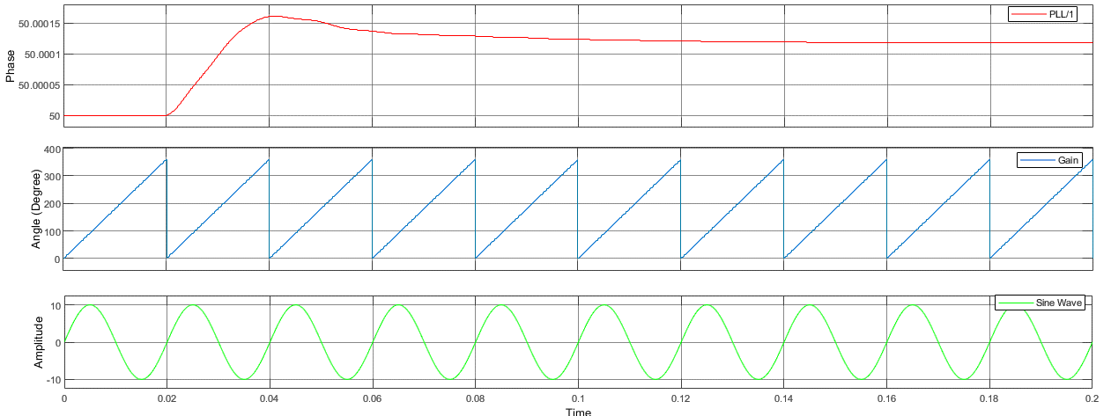

*Fig 2.9: Input & Output waveform for Phase- Locked Loop circuit*

* **PWM Generator**

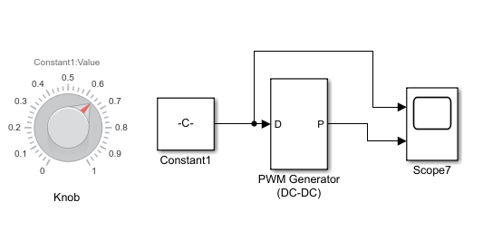

*Fig 2.10: Block diagram of a PWM generator circuit*

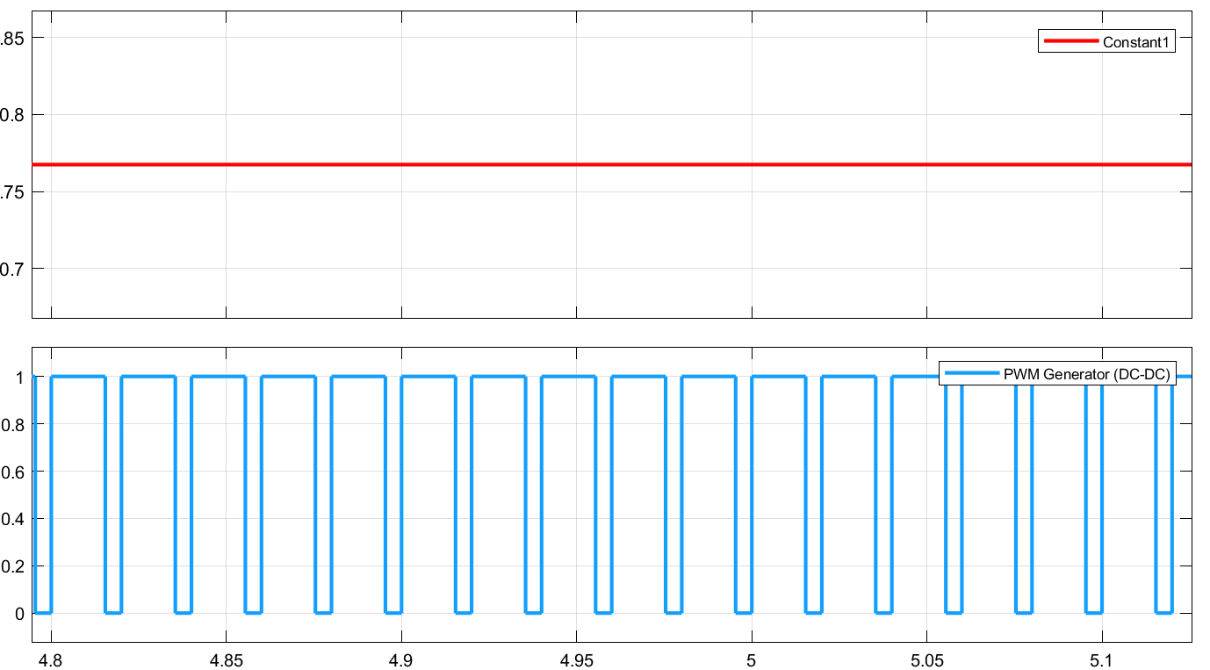

*Fig 2.11: Constant & PWM waveform for PWM generator*

* **Half-wave Rectifier**

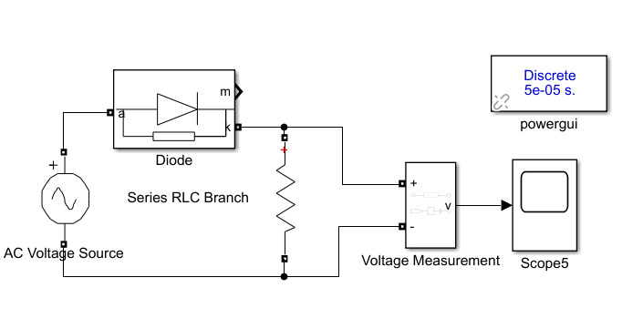

*Fig 2.12: Block diagram of a half-wave rectifier circuit*

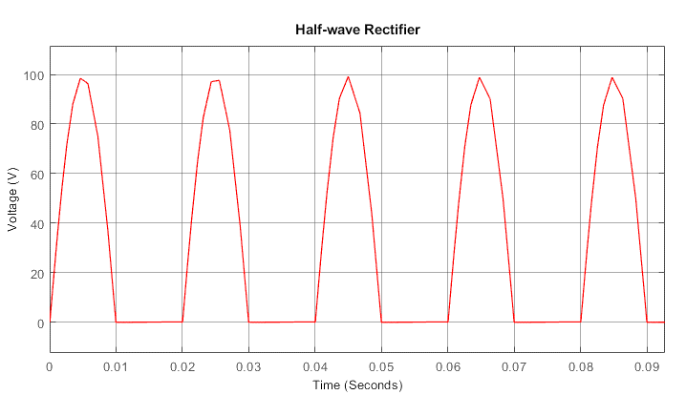

*Fig 2.13: Output waveform using half-wave Rectifier circuit*

* **Full-wave Rectifier**

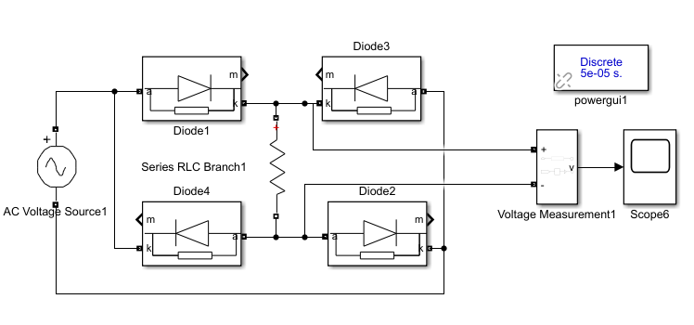

*Fig 2.14: Block diagram of a full-wave rectifier circuit*



*Fig 2.15: Output waveform using full-wave Rectifier circuit*

* 1. **Discussion & Conclusion**

MATLAB Simulink is a powerful and flexible computational tool that is used extensively in academia and research worldwide.

Through this experiment, different types of blocks from the library function 'Simscape' from the library browser were introduced and implemented to PLL circuits, sample and hold circuits, PWM generator (DC-DC) and rectifier circuits (half-wave, full-wave). MATLAB function, mean block, and absolute block were also implemented in different circuit connections. In the end, outputs were viewed through a scope. As a result, the experiment was carried out correctly and the objectives were met.